STAFF

Practice Manager Pauline Tudor
Nurse Practitioner Joanne Anderson
Pharmacist Jack Smith
Health Care Assistant Kelly Lunt Secretary Suzanne Emmett
Administrator Joanne Whitley
Receptionists Val Latham
Lynn Lacy
Sue Kinney
Hannah Timmins
Tina Bodell
Megan Reinard

OPENING HOURS

Monday to Friday 08:00 to 18:30

All surgery sessions and clinics are available by appointment only
SERVICES & CLINICS
Diabetes
Coronary Heart Disease
Vascular Disease
Hypertension
Stroke/CVA
Asthma
COPD
Phlebotomy
Well Women/Cervical Cytology
Family Planning
Sexual Health Screening
H Pylori Screening
Minor Surgery (joint injection/cryotherapy)
Child Health Surveillance
Childhood Immunisation
Travel Vaccines
NHS Health Checks
Non-NHS services inc. Reports and Examination

Townsend Medical Centre
98 Townsend Lane
Liverpool L60BB
Tel: 0151-295-9510
Fax: 0151-295-9511

Practice Leaflet
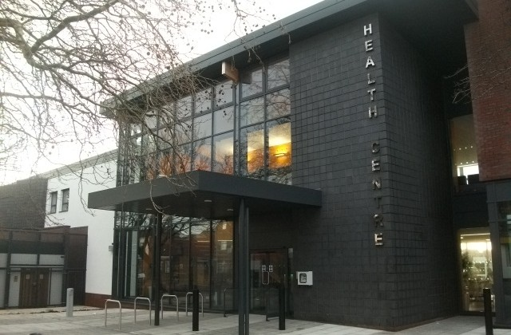
DR JOS MENDIGUREN LMS, BILBAO SPAIN
DRCOG, DFFP, JCPTGP
DR PRAGYA KUMAR MBBS, BDS MSc
DR SEEMA BALAKRISHNA MBBS INDIA

New Patients
We welcome all requests for new patients to join our list that are resident within the practice boundary (certain parts of L4.L6.L13) Patients are registered with the practice this means you can see any doctor within the practice subject to availability. When you first register you will be asked to complete a questionnaire and a registration form (GMS1), you will be given an appointment for a health admin check and we will record detailed information regarding your past and present medical history, it is essential you tell us as much information as it can take up to 6 weeks for your medical records to arrive.

Making an Appointment
All consultations are by appointment only, unless otherwise stated. Each appointment is booked at 10 minute intervals, 15 minute intervals for the nurse practitioner and practice nurse. Appointments are available on a daily basis or you can book in advance 3 to 4 weeks ahead. On arrival for your appointment please report to reception or use the automated arrivals screen situated in the waiting room. If you feel very poorly while waiting to be seen, please inform a member of staff and we will endeavour to get you seen as soon as possible. We aim to keep the average waiting times to between 10 and 20 minutes, however this cannot always be adhered to due to unforeseen circumstances or emergencies. If you find you have been waiting more than 30 minutes please check back at reception. When a patient requests an urgent appointment and all the appointments are taken for the day, your name will be placed on a triage list and a doctor will telephone you back. Please expect to be asked brief details of your complaint by our admin staff, the doctor needs to know this. The doctor will then telephone you and decide based upon your symptoms the best course of action whether this be an urgent appointment, next day appointment or advice etc.
To make an appointment you can:
- Ring the surgery
- Request an appointment in person (face to face)
- Request an appointment via Patient Access Online (password and pin required) please ask at reception
The doctors at the practice are happy to speak to patients via the telephone with non-urgent queries regarding medication; investigations etc please ask the receptionist if you require this service. We aim to return your call on the same day as your request.
The practice also uses SMS to remind you of your appointment. Please keep your telephone numbers up to date and if you change it let us know.

Home Visits
Home visits are available for those patients who are housebound. If you require a home visit, if possible, please telephone the surgery before 11am as this is the time when the doctors plan their home visits. Please expect to be asked by staff the nature of your illness and a contact telephone number. Out of hours emergencies 18:30 to 08:00 and Weekends, are covered by the deputising service, UC24.

Repeat Prescriptions
All prescriptions are computer generated, and if the doctor agrees you may order your prescription by indicated the items you require on your computerised order form. Orders for repeat items can be made in the following way:
- Place your request in the prescription box at reception
- Via fax to 0151295 9511
- Via post enclosing a stamped addressed envelope
- Direct online via Patient Access (please ask for a registration form at reception)
- Via a local pharmacy who provide order and collection services
We do not take prescription requests via the telephone as errors can easily be made.
We require 48 hours’ notice to process your order, this excluding weekends
The Practice participates in Electronic Prescribing, this is when the patient nominates a pharmacy, and your prescription is then sent electronically to your nominated pharmacy, this saves not having to collect from the surgery and saves time

Complaints and Suggestions
Your views and ideas are very welcome. Please place any suggestions or ideas you may have in the suggestion box at reception. If you have a complaint please ask at reception for a copy of our complaints procedure.

Patient Participation Group
The practice welcomes patients to join our ‘Patient Participation Group’ if you are interested in becoming a member of the group please ask at reception for details on joining.

Patient Confidentiality
Information about you, your medical treatment and family background may be recorded either on paper or on computer files. This information is vital to the proper operation of the NHS and is needed to give you and others the best possible healthcare. More information regarding how we use this information is available on a separate leaflet which is available at reception.

Do you need help communicating?
Please inform our reception staff if you have any communication needs e.g
BSL Interpreter, Language Interpreter or information in braille or large print.
We will do our very best to meet your needs and we will ensure that any other health services that we may refer you to will be aware of your needs

